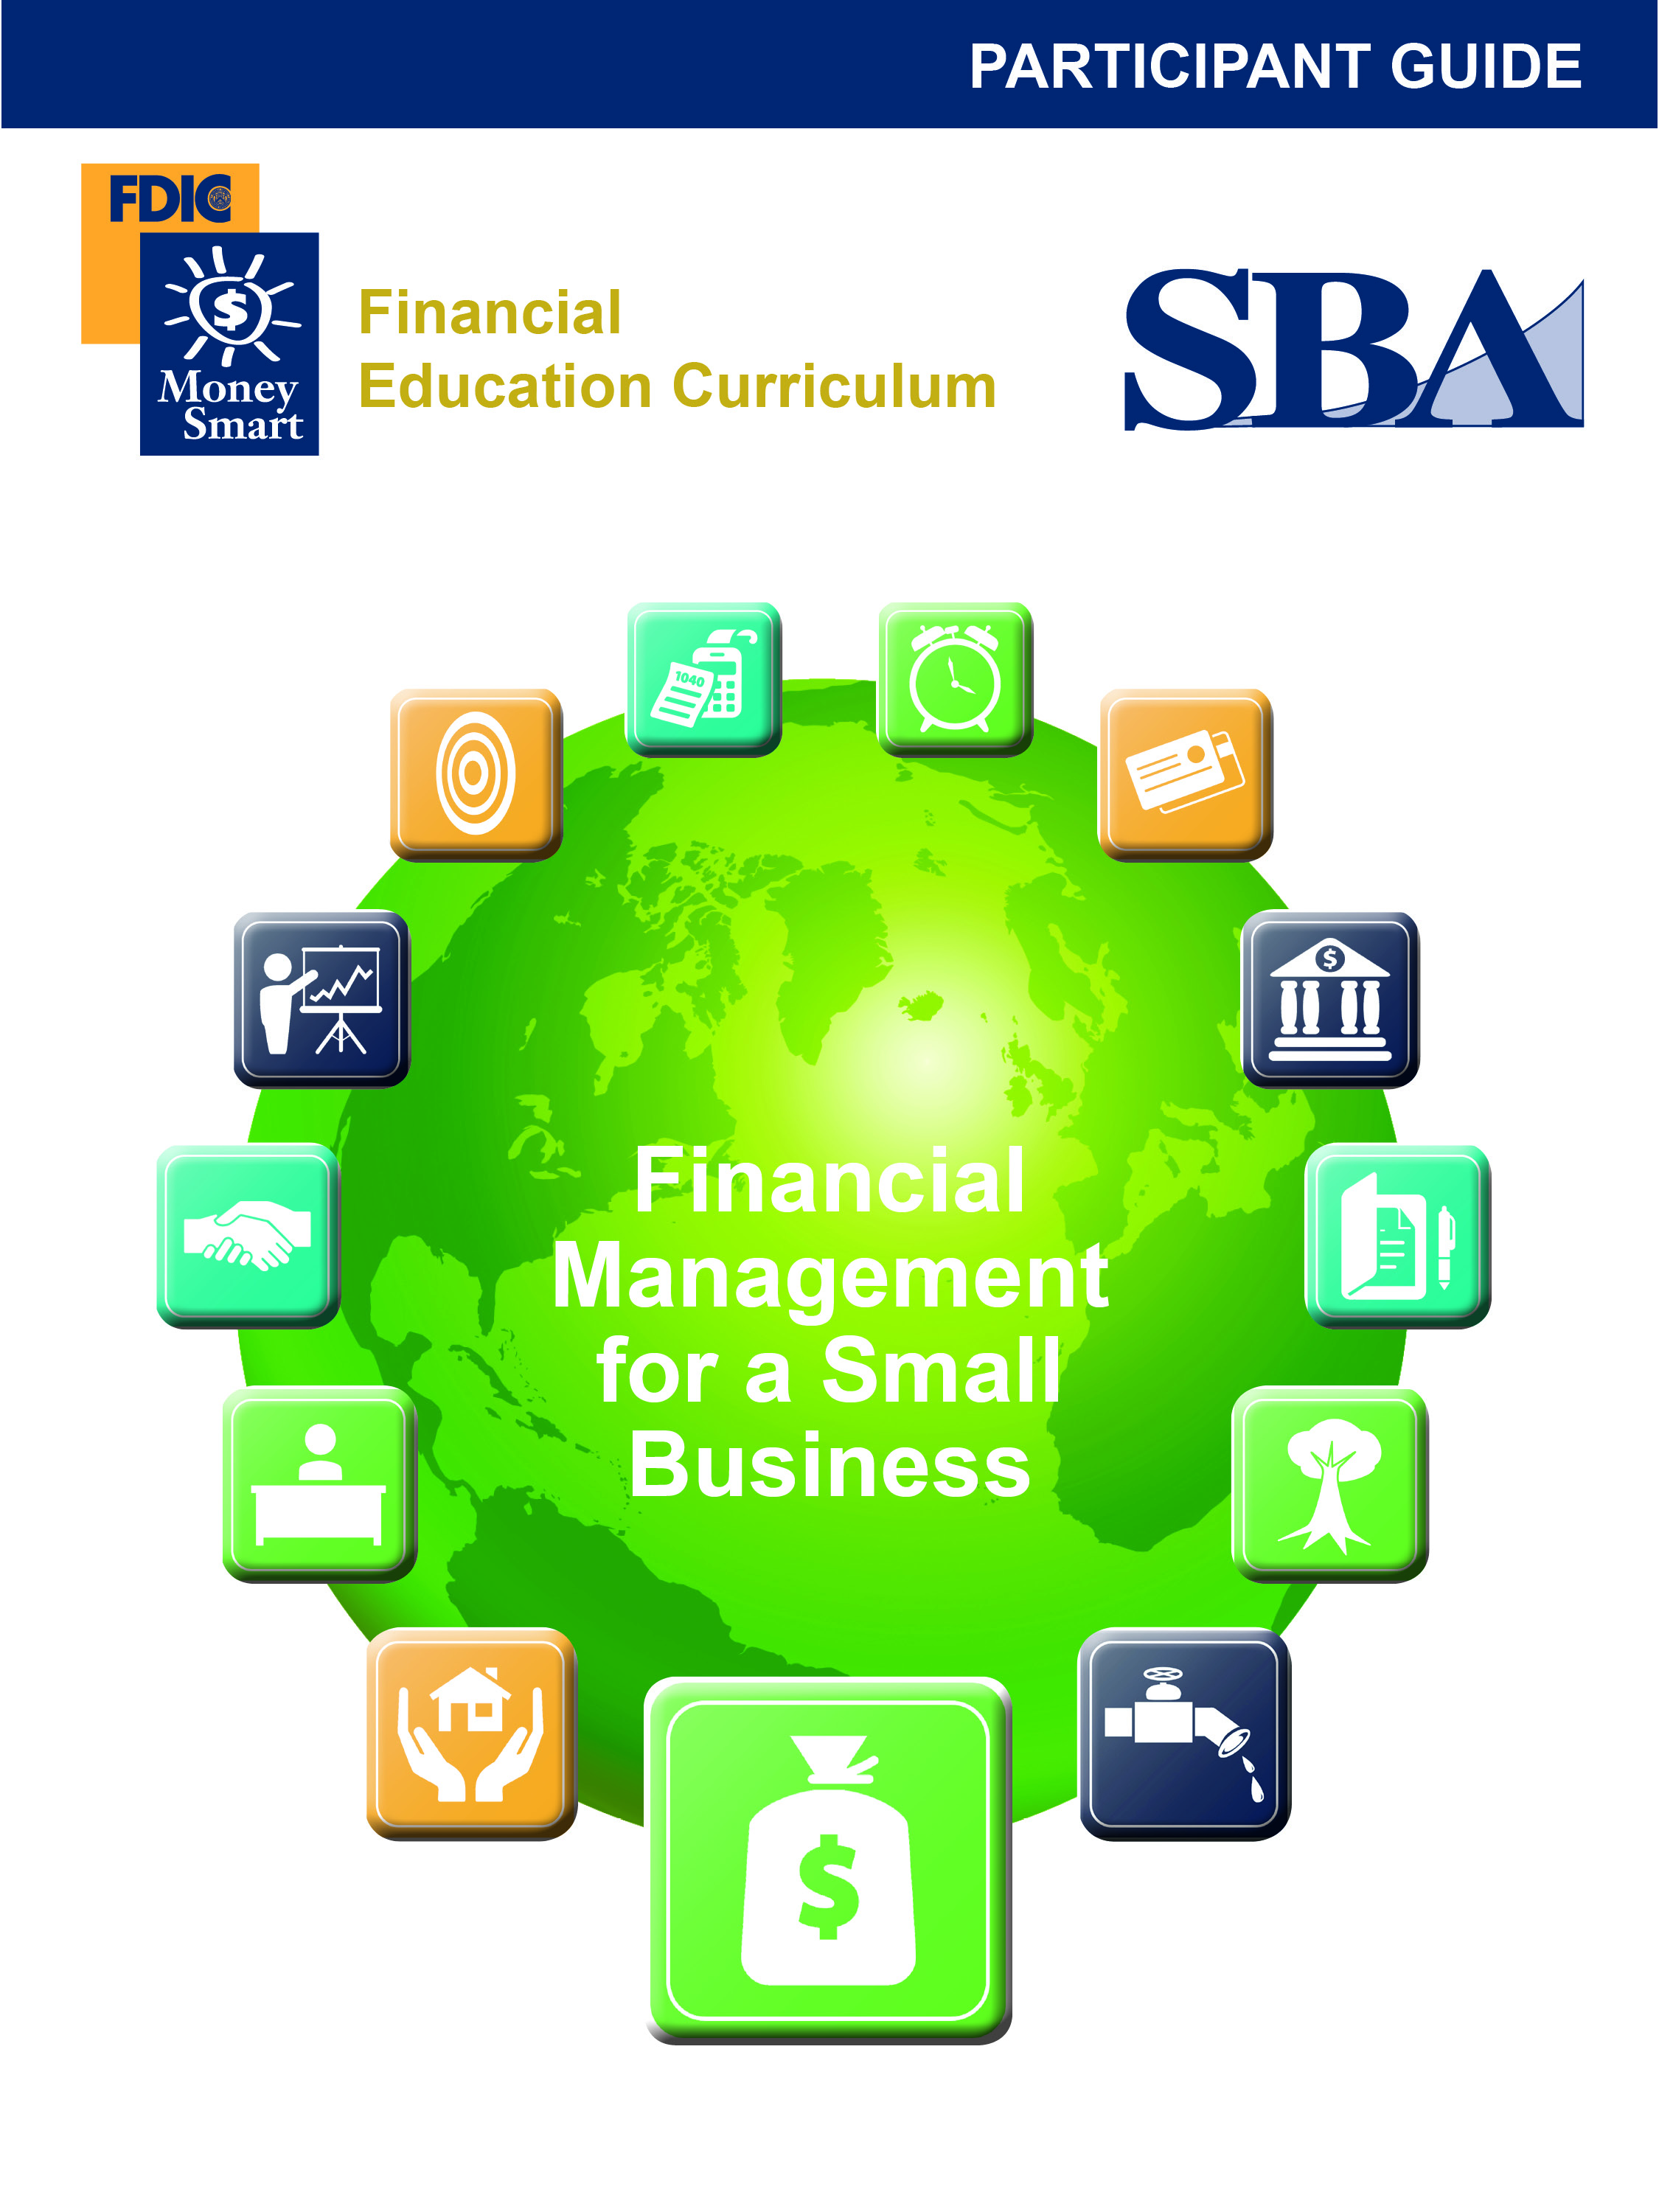
Table of Contents
Revision Date: 09-2011
Welcome 3
What Do You Know? 4
Pre-Test 5
Benefits of Financial Management 7
Budgeting 7
Discussion Point #1: Budgeting 7
Bookkeeping 9
Financial Management Software 9
Financial Statements 10
The Balance Sheet 10
Discussion Point #2: Balance Sheets 13
Cash Flow Projections or Statements 13
Discussion Point #3: Cash Flow 14
Profit and Loss (P&L) Statement 16
Discussion Point # 4: P&L Statements 16
Business Financing 18
Loans 19
Key Points to Remember 22
For More Information 23
Post-Test 25
Evaluation Form 27

DISCLAIMER

These training materials are intended as general guidance only and may or may not apply to a particular situation based on the circumstances. The materials do not create any legal rights or impose any legally binding requirements or obligations on the Federal Deposit Insurance Corporation (FDIC) and U.S. Small Business Administration (SBA). The FDIC and SBA make no claims or guarantees regarding the accuracy or timeliness of this information and material.

The content of this training material is not designed or intended to provide authoritative financial, accounting, investment, legal or other professional advice which may be reasonably relied on by its readers. If expert assistance in any of these areas is required, the services of a qualified professional should be sought.

Reference to any specific commercial product, process, or service by trade name, trademark, manufacture, or otherwise does not constitute an endorsement, a recommendation, or a preference by the FDIC and SBA or the United States government.

Welcome
Welcome to Financial Management. By taking this class, you are taking an important first step to building a better financial future for your business. This guide accompanies the Financial Management PowerPoint Presentation.

Objectives
After completing this training, you will be able to:
- Explain the concept of financial management and why it is important to a small business and its owner
- Identify financial management practices, rules, and tools commonly available to small businesses
- Explain how financial management practices, rules, and tools work
- Explain financial management basics for a small business, including:
  - Start-up financing
  - Financing for a growing business
  - Financing working capital
  - Financing fixed assets

What Do You Know?

Financial Management
Instructor: _____________________________________________________ Date: ____________________
This form will allow you and your instructors to see what you know about financial management, both before and after the training. Read each statement below. Please circle the number that shows how much you agree with each statement.

 | Before Training |  |  |  |  |  | After Training
 | Strongly Disagree |  | Disagree |  | Agree | Strongly Agree | Strongly Disagree | Disagree | Agree | Strongly Agree
- I can explain the concept of financial management and why it is important to a small business. | 1 | 2 |  | 3 |  | 4 | 1 | 2 | 3 | 4
- I can identify financial management practices, rules, and tools that are commonly available to a small business. | 1 | 2 |  | 3 |  | 4 | 1 | 2 | 3 | 4
- I can explain how these financial management practices, rules, and tools work. | 1 | 2 |  | 3 |  | 4 | 1 | 2 | 3 | 4
- I can describe some of the features and benefits of three financial statements: balance sheet, cash flow statement, and profit and loss statement. | 1 | 2 |  | 3 |  | 4 | 1 | 2 | 3 | 4
- I can explain the benefits of using “off –the-shelf” accounting software. | 1 | 2 |  | 3 |  | 4 | 1 | 2 | 3 | 4
- I can explain financial management basics for a small business. | 1 | 2 |  | 3 |  | 4 | 1 | 2 | 3 | 4
- I can explain the basics of start-up financing. | 1 | 2 |  | 3 |  | 4 | 1 | 2 | 3 | 4
- I can explain the basics of financing for a growing business. | 1 | 2 |  | 3 |  | 4 | 1 | 2 | 3 | 4
- I can explain the basics of financing working capital. | 1 | 2 |  | 3 |  | 4 | 1 | 2 | 3 | 4
- I can explain the basics of financing fixed assets. | 1 | 2 |  | 3 |  | 4 | 1 | 2 | 3 | 4

Pre-Test

Test your knowledge of financial management before you go through the training.

- Which of the following are reasons for good financial management? Select all that apply.
  - Helps to show which products or services are profitable
  - Provides information on the size of a loan a business can afford
  - Helps in deciding what inventory a business should purchase
  - Provides a tool for planning to reach new markets

- New businesses should start financial management with a(n) _______________________?
  - Business credit card
  - Budget
  - Inventory purchase
  - Profit and loss statement

- Sound bookkeeping is the basis for all financial management.
  - True
  - False

- When business owners pay themselves, it is called _______________________.
  - Owner’s draw
  - Check cashing
  - Profit and loss
  - Ownership transfer

- What is the definition of cash flow?
  - Sales minus cost of goods sold
  - Moving cash in or out of a business
  - Balance of cash received less the amount of cash paid out over a period of time
  - Both b. and c.
  - All three: a., b., and c.

- Which of the following is a good use of a cash flow projection? Select all that apply.
  - Setting sales and expense goals
  - Determining the breakeven point for a business
  - Tracking sales
  - Planning equipment purchases
  - Tracking liquidity

- What is the basic formula for a profit and loss statement?
  - + Sources of Cash
– Operating Uses of Cash
– Non-operating Uses of Cash
= Ending Cash
  - + Sales
– Cost of Goods Sold
= Gross Profit
– Overhead
= Net Profit
  - + Purchase Price
– Cost of Goods Sold
= Profit
  - + Cash Flow from Operations
+ Cash Flow from Financing
+ Cash Flow from Investments
= Net Cash Flow

- For most small businesses, debt financing comes from owner or family savings and is frequently the only source of funds for start–up small businesses.
  - True
  - False

- Which of the following might be an element of a small business loan package? Select all that apply.
  - Business plan
  - Business financial statements
  - Business tax returns
  - Credit report
  - Collateral
  - Personal financial statements
  - Personal tax returns
  - Purchase agreements
- Of the following financial management statements, which is the most important?
  - Balance Sheet
  - Cash Flow Statement
  - Profit and Loss Statement
  - All of the above
  - None of the above

Benefits of Financial Management
Quality financial management offers many benefits to you as a business owner. Financial management includes bookkeeping, projections, financial statements, and financing, which forms the foundation for reaching your goals through sound business decisions.

Financial management is one of your main avenues to success as a business owner. Financial management is the way you know if you are making a profit. Financial management helps you decide what you can afford in terms of store or office location, inventory purchases, employees, and equipment. You need sound financial information to set your prices and select your vendors. Financial management gives you the tools to plan for overall business growth, for diversification of your product lines, or for reaching new markets. Financial management helps you decide which products, services, and markets are profitable. Effective financial management gives you tools to chart your course into the future, adjust your direction when needed, and help you find your way through challenging times.

If your business growth requires financing (loans), financial management provides the information to know how much you can afford for your business. Financial management gives you not only the documentation needed for a loan application, but also helps you discuss your business circumstances with a lender in terms that improve your ability to qualify for the loan.

Budgeting
Creating a budget is the first place to start with your financial management practice. A budget is a list of all your (monthly or yearly) expenses, organized by categories. A budget is a tool that helps you:
- Track all your business expenses
- Plan for the future
- Economize when you need to
- Plan for expansion
- Make a profit

Once you create a budget, use it to compare what you have budgeted with your actual expenditures.

Discussion Point #1: Budgeting
Use the sample business budget on the next page for this discussion. Review each category.
What budget categories do you use?

Budget Categories

Category | Monthly Budget | Actual Monthly  Expenditures
Rent
Utilities
Telephone and Internet
Insurance
Employees or Contractors
Office Supplies
Inventory Purchases
Permits and Licenses
Dues, memberships, subscriptions
Income Taxes
Owner’s Draw
Travel
Interest
Bank Service Charges
Postage
Legal and Accounting
Other
TOTAL

Bookkeeping
Bookkeeping is the organized process of tracking all income and expense transactions. Bookkeeping is a critical component of financial management, which leads to better business decisions regarding financing, taxes, owner’s draw, and retirement.

Here are ten basic bookkeeping steps:

- Obtain business accounting software. Proper software selection is critical for success.
- Open a separate business checking account. Do not mix business and personal checking accounts.
- Reconcile your checking account. Each month, reconcile your account using business accounting software or a cloud computing reconciliation process.
- Track sales. Create an airtight system for tracking sales using tools such as a register tape, invoices, and a sales book. Always use this sales tracking system.
- Deposit all sales. Using the duplicating deposit slips, deposit all sales in your business checking account. Alternately, “remote deposit capture” (RDC) may be available for depositing checks—this technology allows you to deposit a check into your account from your office by sending the bank an electronic image of the check. Total sales should equal total deposits. Do not spend cash sales. Link all forms of sales documentation (such as invoices, cash register tapes, and sales books) with a specific deposit.
- Write business checks for all business expenses (or use a business check card). Do not use a petty cash system until you are experienced at bookkeeping.
- Obtain a separate business credit card. If you plan to use a credit card for business expenses, consider obtaining a card in your company’s name. Doing so will help you keep track of business expenses.
- Pay business expenses first. Most businesses start out as a sole proprietorship. In sole proprietorships, you, the owner, do not get a salary; rather you take an owner’s draw. A common question is how much draw to take? Here’s a rule of thumb: Sales pays for business expenses first, personal expenses second (step 10, below).
- Run a profit and loss (P&L) statement. A checking account balance is not a good indication of how much profit the business has made or what amount is available for owner’s draw. A P&L statement can provide a better picture of the financial health of the organization.
- Pay yourself with owner’s draw. Owners should pay themselves by writing a check or making an electronic transfer from the business account to a personal account. If you are a sole proprietor, assign those draw checks to an equity account called “Draws.”

Financial Management Software
Financial management software makes it easy to organize and complete daily accounting tasks such as invoicing, making payments, tracking revenue and expenses, and paying wages. It also creates accounting reports, such as cash flow projections or statements, profit and loss statements, and balance sheets. In addition to creating reports, this software allows business owners to track the financial health of their business. Off-the-shelf accounting or financial management software packages are invaluable for small business owners. If this type of technology is new for you, seek out an introductory course at a local community college or community development center. Bookkeepers, accountants, and CPA’s can also help you select and set up a financial management package that fits your needs. With any financial management software it is imperative that you are set up correctly and that you are trained on how to enter data. Many business owners hire bookkeepers to enter data for them to ensure accuracy. Do not use paper to run your business or keep track of your income and expenses.

Financial Statements
Financial statements are reports about a business’s financial health and cash flows. There are three basic statements:
- Balance Sheet
- Cash Flow Projection (also called a Cash Flow Statement)
- Profit and Loss Statement (P&L) (also known as an Income Statement)
Business owners, accountants, lenders, and others use these financial statements to gain insight into the overall health of a business. These financial statements tell a story about the business (without the business owner ever speaking) and provide answers to many questions such as:
- Can this business generate cash flow?
- Where is the cash coming from?
- Is the cash being used wisely?
- Is the business capable of paying back its loans?
- Is the business capable of taking on more debt or loans?
- Are there any trends occurring in the business that could be signs of trouble?
- Is the company profitable?
- How quickly does this business turn over inventory?

These three financial statements, when correctly compiled, provide a wealth of insight and information. They can be used to make smart business decisions. Financial statements can be easily generated with off-the-shelf accounting and bookkeeping software packages.

The Balance Sheet
A balance sheet is a snapshot of a business at a specific point in time, such as the first day a business opens its doors. Subsequent balance sheets are prepared at the conclusions of accounting periods, such as monthly, quarterly, or year-end.

A balance sheet provides helpful information. It reports the dollar value of a company’s assets, liabilities, and owner’s equity as of a specific date. Assets include cash, accounts receivable, inventory, investments, land, buildings, equipment, and some intangible items and other assets. Liabilities are the debt or obligations of a company and include loans payable, accounts payable, taxes payable and more. The Owner’s Equity shows the amount of assets that came from the owner and not creditors.

The balance sheet tells a story about the assets your company controls such as cash, equipment, and inventory. The balance sheet explains who owns those assets: someone else (creditors) or you (owner’s equity), how much working capital (cash) you have to run your business and if the company is highly leveraged or carrying too much debt. Lenders use balance sheets as part of the loan application process. They will compare how much of your own money you plan to invest against the amount you need to borrow. The higher the proportion of owner’s equity to debt, the better. Balance Sheets support other good business decisions as well. At the end of an accounting period or at the end of each year, you need to create a closing balance sheet. Opening and closing balance sheets are compared, like before and after pictures, to identify what has taken place over a specific period of time. You can compare balance sheets from year to year to identify trends and other useful factors.

In the simplified balance sheet example below, the right column shows that the owner invested $35,000 of her own money (Owner’s Equity) in her business. She borrowed $20,000 (debt) for a total in-flow of $55,000. The left column, Assets, describes how she used that money. In this example, she allocated $25,000 for equipment, $20,000 for inventory, and has $10,000 cash or working capital remaining to run her business.

Company XYZ Balance Sheet Date prepared: 9/15/2015

Assets | Liabilities (Debt)
Cash $10,000 | $20,000
Equipment $25,000 | Owner’s Equity
Inventory $20,000 | $35,000
Total | Total
$55,000 | $55,000

Notice that the two sides of a balance sheet must always balance. The totals on both sides must be the same: Assets (on the left) must equal Liabilities and Owner’s Equity (on the right). This is a simplified example of a balance sheet. Please see the next page for a more detailed example.

Detailed Balance Sheet Example
Here is a more advanced balance sheet which includes more asset and liability categories. To learn more about balance sheets, visit the SBA website: www.sba.gov/content/financial-statements.
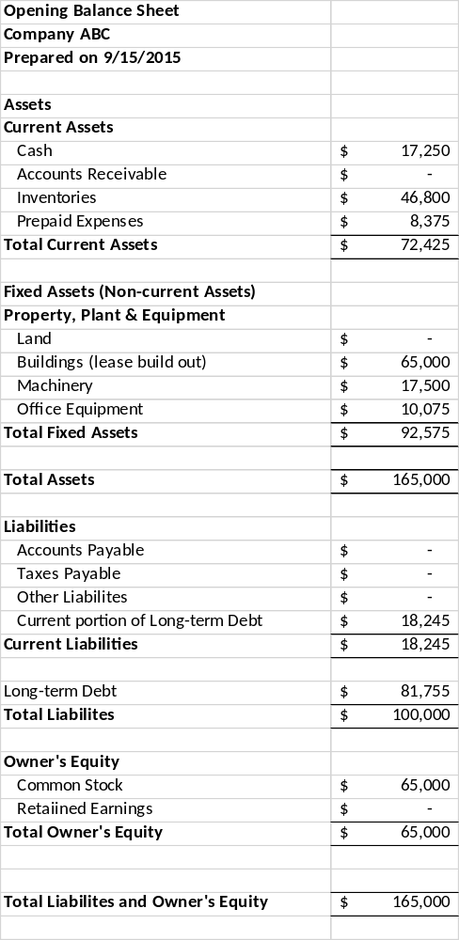

Discussion Point #2: Balance Sheets
After reviewing the sample balance sheet, what story does it tell?

Cash Flow Projections or Statements
Cash flow can be defined two ways:
- Balance of cash received less the amount of cash paid out over a period of time
- Moving cash in or out of a business

A cash flow projection is a financial statement that shows how cash is expected to flow in and out of a business over a future period of time. A cash flow statement is historical because it portrays what has happened before. Many people use both terms – projection and statement – to refer to the same item.

A cash flow projection is used to see if projected cash receipts (in flows) will be sufficient to cover projected cash disbursements (out flows). A business can be profitable and still run out of cash. As an investment banker might say, “Cash flow projections provide the visibility needed to avoid liquidity problems.” In other words, a cash flow projection is a tool to help you manage your cash so you can pay your bills on a timely basis and keep the doors of your business open.

A cash flow projection is a great tool for setting sales goals and for planning for expenses to support those sales. A related use for a projection is to determine your breakeven point during a start-up or expansion phase. If you need to plan for a large expenditure, such as an equipment purchase or move to a new location, a cash flow projection is the perfect tool. Similarly, if you have a seasonal business with large inventory purchases, a projection can help you have the cash on hand to make a large inventory investment when you need it.

A P&L statement can mask cash shortages if you use accrual accounting. A cash flow projection helps you see the cash status of your business now and plan into the future. A cash flow projection is a good way to prepare and plan for your financing needs and is often a required part of a business loan application.

Cash Flow Projection
Let’s look at a sample cash flow projection. The first set of rows, titled Sources of Cash, document all sources of incoming cash, including cash from customer sales, interest earned, loan funds, and current checking and savings account balances. The second section, Operating Uses of Cash, contains all those expenditures associated with the day-to-day buying and selling process. Most of these expenses show up on the P&L statement. The third section, Non-Operating Uses of Cash, show expenses that normally show up on your balance sheet: equipment purchases, the principle portion of loan payments, inventory, taxes, and owner’s draw. Subtract your Uses of Cash from your Total Cash Available, and you have Ending Cash for the month. Ending Cash for one month becomes Opening Cash for the next month.

Discussion Point #3: Cash Flow
Take a few minutes and review the Sample Cash Flow Projection on the following page.
After reviewing the spreadsheet, which month had a positive cash flow?

Here are some strategies for creating a positive cash flow:
- Increase the number of items sold
- Increase the price of items
- Reduce expenses
- Change the timing of expenses
- Save money to have sufficient Opening Cash to get through the “start-up” period
- Obtain sources of cash other than sales, such as a line of credit
- Reduce or change the timing of your owner’s draw
- Research vendor options for buying inventory at lower price or obtaining credit from vendors
- Establish policies to get paid sooner from customers

Note: for more detailed information about cash flow, consider attending the Cash Flow Management module in this Money Smart for Small Business series.

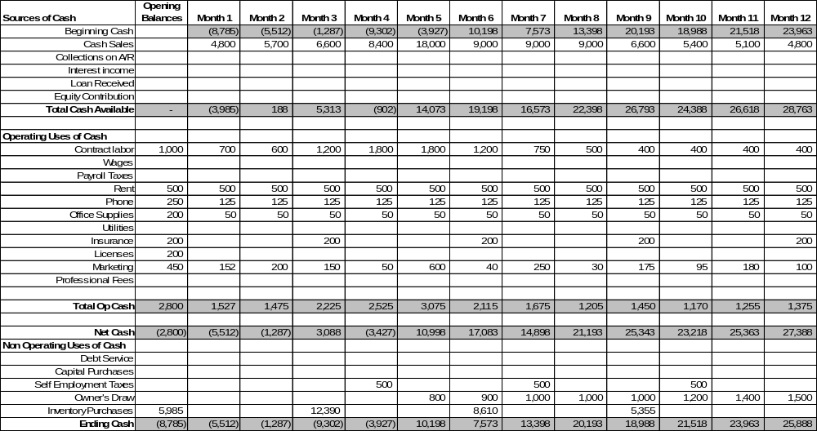
Sample Cash Flow Projection

Profit and Loss (P&L) Statement
The P&L statement is the best tool for knowing if your business is profitable. A P&L statement measures revenue (also called sales or income) and expenses over a month, quarter or year. With it you know if you have made a profit (and how much) or if you have incurred a loss.

The most important financial management report is the P&L statement. A P&L statement will reflect your business decisions on the basic buying and selling process. A P&L will tell you how well you are managing your business and provide information on how to grow your business.

Basic Formula for P&L Statement
+ Sales
– Cost of Goods Sold
= Gross Profit
– Overhead
= Net Profit
- Sales (also called Income or Revenue): Total amount from selling your product or service during a certain time period.
- Cost of Goods Sold: Total expenditure for inventory items which customers buy. Cost of Goods Sold consists of the cost of purchasing the items, freight, manufacturing costs, modification costs, and packaging. For services, this is the cost of providing the services, including labor, material used, and transportation.
- Gross Profit: Sales less Cost of Goods Sold.
- Overhead: Expenses associated with your ongoing business operation, such as rent or utilities.
- Net Profit: Gross Profit less Overhead. Net Profit is what remains to pay for expansion, equipment, loan repayment, income taxes and owner’s draw.

Compiling a P&L Statement
All quality business accounting software programs compile a P&L statement at the push of a button. The accuracy of your P&L statement will depend on how it is set up for your company and your input data. Print out your P&L regularly to track your business progress. Use your P&L statement as the basis for building a cash flow projection.

Discussion Point # 4: P&L Statements
Please review the P&L statement on the next page.
Does any problem stand out?

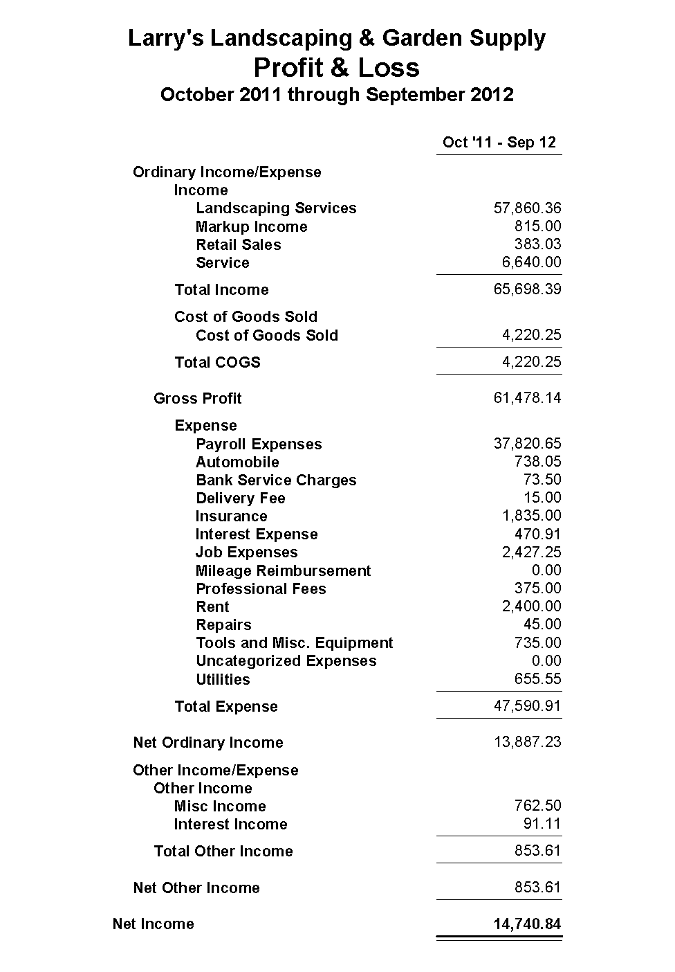
Sample P&L Statement

Business Financing
The following items are core elements in business financing:
- Equity financing: Invested funds that stay in the business, often permanently. For most small businesses, equity comes from the owner or from family savings and is frequently the only source of funds for start–up small businesses. For large, fast-growing quality companies, venture capital can sometimes be accessed for equity.
- Debt financing: Borrowed funds that are paid back. The cost of debt financing is interest paid to the lender.
- Working capital: The money that is used to pay for the daily operations of the business incurred in the short-term, such as inventory and overhead expenses.
- Fixed asset financing: Used for purchasing equipment, vehicles and real estate.

Here are some “do’s and don’ts” for small business financing.
- Invest your own money: You need to invest your own money first, before you ask for equity or debt from other sources. Having your “skin in the game” shows your commitment and also shows your skill in running a successful business.
- Earn the right to borrow: Generally, borrowing is not a “right.” Rather, the ability to borrow is an earned privilege. To obtain others’ investment, you need to demonstrate your ability to manage debt well and run a profitable business.
- Show profitability: Profits are what lenders or investors want to see. Do not let lax management inhibit a healthy bottom line.
- Understand and retain working capital: Experienced business owners know that working capital is critical. On the other hand, working capital is sometimes overlooked or misunderstood by new business owners. As your business grows, the amount of working capital cycling through the business to support operations should grow. Successful business owners stay aware of the working capital needed to grow and sustain their businesses.
- Be lean on fixed assets: New business owners sometimes think they need to purchase fixed assets to start or grow a business. Fixed assets consume precious working capital (through down payments and monthly loan payments), so whenever possible new business owners should buy as few fixed assets as possible. When acquiring fixed assets, new business owners should consider buying used assets or leasing the assets.
- Match sources and uses of funds: When financing, current assets (accounts receivables and inventory) should be financed with current liabilities (line of credit or credit card). Fixed assets should be financed with long term loans that match the use life of the asset. New business owners can make the mistake of buying a fixed asset with short-term debt, forcing them to pay for an asset faster than that asset can generate profits for the loan repayment.
- Understand your financial statements: Most types of financing require an application process that asks for business financial statements such as your P&L statement, balance sheet and a cash flow projection. You want to know your financial statements well and be able to discuss them intelligently with a lender.
- Understand your collateral options: Most loans require assets (collateral) be pledged as security for a loan. In the event a borrower defaults on a loan, the collateral may be sold. Be prepared to discuss collateral options with your lender.
- Understand risks and costs for loan types: Each type of loan carries associated risks and costs. For example, while a credit card may be easy to use, credit card financing may be a very expensive form of credit. In many cases a small business loan, guaranteed by the SBA, will be a better form of loan than a credit card.
- No grants: There is a common mistaken belief that government grants are available for businesses. With a few rare exceptions, grants are not available to business owners.
- Shop around: Shop around for the best loan. You may want to start where you already have a personal relationship. For example, if you have a personal account at a bank, start there. Check out SBA loan guarantees, which are available at most commercial banks.
- Separate your personal and business records and funds: Do not combine personal and business finances in the same bank account. In the long run, “clean” books keep accounting costs down and protect you in the event of a lawsuit or an audit. If you need to transfer funds from your personal accounts into your business accounts, or from your business accounts into your personal accounts, transferring is an easy process with online banking and it generates a record of the activity, which is required for accurate bookkeeping.
- Get expert advice: You can get mentoring and advice with the SBA. Do not rule out banks, especially ones with which you have a good working relationship. The FDIC has educational resources that can help as well.

Loans
Here are some steps you can take to prepare for a loan.
- Have a business plan (including a profit plan): The best way to get a loan is to have a solid plan for using the loan. Make sure you have a good up-to-date business plan which incorporates a profit plan. A profit plan will show how the loan proceeds will be used to increase sales and profitability. Showing a lender a reasonable proposition with a solid repayment plan will help as well. Your plan should include any research you have undertaken to establish your costs and your marketing or sales strategies. Typically a business plan will:
  - Have a statement of purpose
  - List the owners of the business
  - Describe the business and how it will make a profit
  - Provide financial statements like a P&L statement and a cash flow projection
  - Provide other documents such as references and proof of insurance
- Know what you can afford: Using the likely loan terms, calculate the amount of funds you will need and the monthly loan payment. Your plan should include a repayment plan with projections that show your ability to make your monthly loan payment.
- Study your financial statements: As mentioned earlier, a lender will want to see your financial statements. Not only do you need to provide accurate current and historical statements, you need to know what your statements say about your business. Be prepared to discuss the details of your statements and explain any issues.
- Check your credit report: You can get a free copy of your personal credit report from each of the three major credit bureaus every 12 months. Study your credit report, make sure it is accurate, fix any inaccuracies, and be prepared to explain any credit issues.
- Establish collateral options: Be prepared to discuss collateral with lenders. When you are purchasing a fixed asset, the asset is often the collateral for the loan. Lines of credit are sometimes unsecured if a business owner can show a strong history of profitability, but it is not uncommon to use personal assets to collateralize a business loan.
- Show your equity contribution: Lenders usually require an equity contribution for a start-up loan or a loan for an expansion project. The required cash contribution can range from 10 to 30 percent of the total project costs.
- Research your financing options: You will need to choose between many lenders and many types of loans. Research your options to ensure you obtain financing from credible sources.

Loan packages require a lot of preparation and documentation. Here is a list to get you started:
- Business plan: Most lenders require a business plan that describes your costs and your management and sales strategies.
- Business financial statements: Lenders generally want to review business financial statements from the past three years, as well as current statements.
- Personal financial statements: A personal financial statement shows your personal assets, liabilities, and net worth.
- Personal and business tax returns: Lenders often ask for up to three years of past tax returns, both business and personal.
- Source and amount of equity contribution: Business loans usually require the business owner to contribute between 10 and 30 percent of total project costs in cash or equity. Include a write-up documenting the amount and source of your equity contribution.
- Credit report: Lenders will order your credit report, but it is important you know what they will see in the report. Make sure you have addressed any credit issues that are contained in the report.
- Collateral: Lenders usually require collateral. Include options for collateral in your application.
- Purchase agreements, appraisals, contracts, and estimates: Include purchase agreements, appraisals, contracts, and official estimates to document costs that pertain to your project.

Qualifying for a Loan
What do lenders look for when evaluating a loan application?
- Good credit score: Your credit report gives the history of how you have managed debt for the past seven years. A good credit score tells a lender that you have the ability to manage and repay a loan.
- Equity contribution: Sufficient equity contribution shows a lender that you have a commitment to the project and the ability to earn, save, and manage money.
- Repayment ability: Lenders often analyze financial statements from the past three years to see if the business has the historic ability to pay debt service. Lender criteria vary, however, you will probably need to show that you have strong profits, good cash management skills, and growth potential. The need to show historical evidence is why it is harder for a start-up business to obtain a loan. On the other hand, while most loan applications require projections, it is more difficult to qualify for a loan on projections alone.
- Loan-to-value ratio: Lenders tend to loan between 70 and 90 percent of the market value of an asset. If you are buying real estate, an appraisal will be used to determine the maximum loan amount.
Start-Up Financing
Here are options for financing a start-up business:
- Equity: Equity is simply—it’s your money. Many businesses are started with savings from a “day job” or through the sale of an asset. You can launch your business by starting small and re-investing the profits over time to build up the business.
- Sweat equity: Sweat equity means “doing it yourself.” Owners of start-up businesses are often a” jack of all trades.” You put in the hours to cover the many activities of your business, rather than hiring others or buying equipment.
- Family: Some business owners turn to their families for an equity contribution.
Understand the different types of financing. For most small businesses, there are three key ways to finance operations:
- Personal lines of credit, such as credit cards (either an owner’s personal card or a business card guaranteed by the owner) or home equity lines of credit (the small business owner’s home serves as the collateral) are commonly used, but there are risks. Small business owners may find a credit card convenient, but it can be an expensive financing tool. Owners using a credit card also can quickly find themselves taking on debt that cannot reasonably be supported by revenues from the business. Interest rates on credit cards are also usually much higher than on business loans. Here are some tips to using a credit card wisely:
    - Get a separate credit card for business use.
    - Use only one credit card, not multiple cards.
    - Keep your balances modest.
    - Pay the balance before the due date to avoid paying interest.
    - Do not use a credit card to prop up an unprofitable business. Remember, profits are the best way to grow your business.
- Business lines of credit, which provide a convenient way for a business to borrow up to a certain dollar amount and repay it in installments with interest over several years, also present risks. Business owners should think carefully before borrowing on a line of credit. Consider how and when the business will generate revenue to repay the loan, and make sure you aren’t using a short-term financing tool to finance costly, long-term investments.
- Business term loans, which establish a set dollar amount to be repaid in installments over three or more years, are commonly recommended for purposes such as financing the purchase of equipment or a vehicle. These loans often are secured by the asset that is purchased. Term loans mean predictable payments for businesses, but unlike lines of credit, a business may have to make a new application if it needs to borrow additional funds.

Looking for a Loan
If you need to borrow money, comparison shop for government-guaranteed loans that may be offered by your bank and a few other financial institutions serving your community. The U.S. Small Business Administration backs a certain portion of loans to help borrowers qualify for attractive financing terms. If you need a loan for less than the lender’s minimum amount, ask your bank for a referral to a lender participating in the SBA’s microloan program, which combines business coaching and technical assistance with access to loans up to $50,000 (although the average loan amount is about $13,000). Also be aware that certain borrowers, such as veterans or victims of disasters, may be eligible for special loan programs. Here are places to look for business financing as well as referrals to local financing:
- Banks: Many banks provide business loans, lines of credit, equipment leasing loans, and SBA-guaranteed loans. Start by gathering information from the bank with which you currently do business. Find out what types of business financing your bank offers. Make an appointment with your bank’s lending officer to discuss products offered by the bank. If your bank is not active in small business lending, ask your accountant or other business owners in your area for referrals to other banks.
- Regional Lending Organizations: Many are nonprofit, community development organizations that have revolving loan programs for business development in their region. To locate these organizations (or organizations that can refer you to lending programs) in your area, search the internet for:
  - Community Development Financing Institutions (CDFI)
  - Small Business Administration (SBA) Resource Partners such as Small Business Development Centers (SBDC), SCORE, Women’s Business Centers, Veterans Business Outreach Centers, and US Export Assistance Centers
  - Your city, county, state, or community economic development department
  - Certified Development Corporations (CDCs), part of the National Association of Development Companies (NADCO)
  - Microenterprise development organizations, part of the Association for Enterprise Opportunity (AEO)
  - SBA lenders, by looking on the SBA website for Community Advantage Approved Lenders
  - Your state USDA Rural Development office
  - Your regional SBA office

Key Points to Remember
- Financing is getting the money you need to start, operate, or grow your business.
- Start with a budget.
- Sound bookkeeping is the basis for all financial management.
- Purchase financial management software and learn how to use it.
- Three statements — balance sheets, cash flow statements, and profit and loss statements — provide a compelling story to describe a business.
- Separate personal and business records and funds.
- Factors that affect your ability to get a loan: credit score, equity contribution, repayment ability, and loan to value ratio.

For More Information
BusinessUSA
www.business.usa.gov

This official portal of the United States government provides guides and resources that help businesses comply with business laws and regulations. It provides self-paced courses on how to apply for financing such as microloans, how to write a business plan, how to register and run a business, and more.

U.S. Small Business Administration (SBA)
www.sba.gov; www.sba.gov/tools; www.sba.gov/tool/sba-learning-center
SBA Answer Desk: 1-800-827-5722
The U.S. Small Business Administration (SBA) website provides resources, answers to frequently asked questions, and other information for small business owners. They provide free online tools and resources at www.sba.gov/tools. The site provides self-paced information on how to write business and strategic plans, how to buy or sell a business, how to compete for government contracts, how to conduct market research, basics of accounting, and more. Also check out the Learning Center: www.sba.gov/tools/sba-learning-center offers a long list of online courses on topics such as attracting investors, cybersecurity, fundamentals of crowdfunding, customer service, and more.

SCORE
www.score.org.
SCORE is a nonprofit association dedicated to helping small businesses get off the ground, grow, and achieve their goals through education and mentorship. SCORE provides a variety of free online resources for start-up small businesses including a gallery of templates for business, finance, and marketing plans. They provide how-to guides and self-paced modules on financing, how to secure contracts, cash flow management, and more. For more information go to www.score.org/startup.

America Small Business Development Center Network
http://americassbdc.org.
The American Small Business Development Center (SBDC) network provides free consulting to small business owners at all stages of development. This excellent resource provides a variety of feedback and planning assistance to small business owners. Their advisors can help connect you to regional and local business resources and lending institutions.

Women’s Business Center (WBC)
www.sba.gov/tools/local-assistance/wbc
Women’s Business Centers (WBCs) is a national network of education centers throughout the United States designed to assist women in starting and growing small businesses. WBCs seek to “level the playing field” for women entrepreneurs who still face unique obstacles in the business world. The network provides comprehensive training and counseling on a variety of topics in several languages.
U.S. Financial Literacy and Education Commission
www.mymoney.gov.
1-888-My-Money (696-6639)
MyMoney.gov is the federal government's one-stop website that provides financial education resources from more than 20 federal agencies.

Federal Deposit Insurance Corporation (FDIC)
www.fdic.gov.
The FDIC preserves and promotes public confidence in the U.S. financial system by insuring deposits in banks and thrift institutions for at least $250,000; by identifying, monitoring, and addressing risks to the deposit insurance funds; and by limiting the effect on the economy and the financial system when a bank or thrift institution fails.

The FDIC encourages bank lending to creditworthy small businesses. The FDIC encourages small business owners with inquiries or concerns about the availability of credit to contact the FDIC Small Business Hotline at 1-855-FDIC-BIZ or www.fdic.gov/smallbusiness. Another FDIC website, www.fdic.gov/buying/goods provides resources to small business owners who want to conduct business with the FDIC.

For more information about the Money Smart for Small Business Curriculum see www.fdic.gov/consumers/consumer/moneysmart.

Local Resources
Post-Test

Now that you have gone through the course, see what you have learned.
- What does good financial management provide? Select all that apply.
  - Backup documentation for a loan application
  - Fixed assets for a loan
  - Help with discussing business circumstances with a lender
  - Collateral for a loan

- A budget is one of many financial management tools.
  - True
  - False

- As a rule of thumb, in a sole proprietorship, “Sales pay for expenses ______________________, personal expenses ____________________.”
  - When they occur … in advance
  - First … second
  - In advance … when they occur
  - Second … first

- It may be a good financial management practice to get a separate business credit card that is used exclusively for business expenses.
  - True
  - False

- How might a business be profitable and still run out of cash? Select all that apply
  - Cash is central to operations, so this would never happen.
  - The business has a backlog of inventory.
  - The amount of cash received is greater than the amount of cash paid out over a period of time.
  - A business has a high amount of receivables because it does an inadequate job of collecting money owed.

- Despite its name, a profit and loss statement is not a tool for knowing if a business is profitable.
  - True
  - False

- What is the basic formula for a profit and loss statement?
  - + Sales
– Cost of Goods Sold
= Gross Profit
– Overhead
= Net Profit
  - + Purchase Price
– Cost of Goods Sold
= Profit
  - + Cash Flow from Operations
+ Cash Flow from Financing
+ Cash Flow from Investments
= Net Cash Flow
  - + Sources of Cash
– Operating Uses of Cash
– Non-operating Uses of Cash
= Ending Cash

- Working capital are the funds needed to run the daily operations of a business, including _______________.
  - Inventory and overhead expenses
  - Fixed assets
  - Equipment, vehicles and real estate
  - Office furniture purchases

- Which of the following is not a good small business financing practice? Select one.
  - Invest personal money first before asking for equity or debt from other sources.
  - Purchase fixed assets as much as possible when starting a new business (for collateral).
  - Current assets (accounts receivables and inventory) are financed with current liabilities (line of credit or
credit card).
  - Fixed assets are financed with long-term loans that match the use-life of the asset.

- Of the following financial management statements, which is the most important?
- Balance Sheet
- Cash Flow Statement
- Profit and Loss Statement
- All of the above
- None of the above

Evaluation Form
Your feedback is important. Please fill out this evaluation of the Financial Management.
Training Rating
- Overall, I felt the module was (check one):
[ ] Excellent
[ ] Very Good
[ ] Good
[ ] Fair
[ ] Poor
Please indicate the degree to which you agree by circling a number.
 | Strongly Disagree |  | Disagree | Neutral | Agree | Strongly Agree
- I achieved the training objectives. | 1 |  | 2 | 3 | 4 | 5
- The instructions were clear and easy to follow. | 1 |  | 2 | 3 | 4 | 5
- The PowerPoint slides were clear. | 1 |  | 2 | 3 | 4 | 5
- The PowerPoint slides enhanced my learning. | 1 |  | 2 | 3 | 4 | 5
- The time allocation was correct for this module. | 1 |  | 2 | 3 | 4 | 5
- The instructor was knowledgeable and well-prepared. | 1 |  | 2 | 3 | 4 | 5
- The participants had ample opportunity to exchange experiences and ideas. | 1 |  | 2 | 3 | 4 | 5
Please indicate the degree of knowledge/skill by circling a number. | None Advanced
- My knowledge/skill level of the subject matter before taking the training. | 1 |  | 2 | 3 | 4 | 5
- My knowledge/skill level of the subject matter upon completion of the training. | 1 |  | 2 | 3 | 4 | 5
Instructor Rating
- Instructor Name:
Please use the response scale to rate your instructor by circling a number. | Poor | Fair |  | Good | Very Good | Excellent
- Made the subject understandable | 1 |  | 2 | 3 | 4 | 5
13. Encouraged questions | 1 |  | 2 | 3 | 4 | 5
14. Provided technical knowledge | 1 |  | 2 | 3 | 4 | 5
- What was the most useful part of the training?
______________________________________________________________________________________________________________________________________________________________________________________________________________________________________________________________________________________________________
- What was the least useful part of the training and how could it be improved?
______________________________________________________________________________________________________________________________________________________________________________________________________________________________________________________________________________________________________

